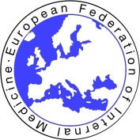 | The Foundation for the Development of Internal Medicine in Europe  and  The European Federation of Internal Medicine | 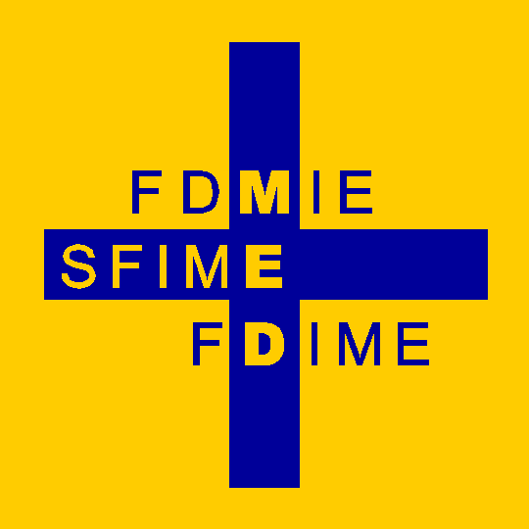

FDIME-EFIM 20th CLINICAL RESEARCH SEMINAR: 06-08 October 2025

Venue : La maison de la Pneumologie, 68 Boulevard Saint- Michel, 75006 Paris, France

Seminar Schedule

Topics For The Course Will Include :

- ➢ Methodological, practical, and ethical issues in clinical trials
- ➢ Clinical epidemiology
- ➢ How to build a clinical trial
- ➢ Workshop of published and on-going trials
- ➢ Differences between industrial and institutional research
- ➢ How to write a medical paper
- ➢ How to write a winning grant application
        - ➢ Short presentations of their own experience by the residents

The structure of the course will permit interaction between residents and speakers, working in small groups on real life examples.

Sunday 5 October Residents Arrive by 19.00 hr at their Hotel located close to the Seminar venue. (Hotel bookings will be arranged for all attendees who will be advised accordingly).

Monday 6 October
09.00 - 09.15 Welcome coffee at the Seminar Venue
09.15 - 13.00 Clinical Research Seminar sessions
13.00 - 14.00 Buffet Lunch – on site
14.00 – 17.30 Clinical Research Seminar sessions

Tuesday 7 October
08.45 - 12.30 Clinical Research Seminar sessions
12.30 - 13.30 Buffet Lunch – on site
13.30 - 18.00 Clinical Research Seminar sessions
20.00 Informal Dinner for Residents & Speakers at a local Restaurant.

Wednesday 8 October
09.00 - 12.45 Clinical Research Seminar sessions
12.45 - 13.30 Evaluation and Closing Remarks by Prof Daniel Sereni.
13.30 - 14.30 Buffet Lunch – on site
14.30 Free time - Residents Depart

