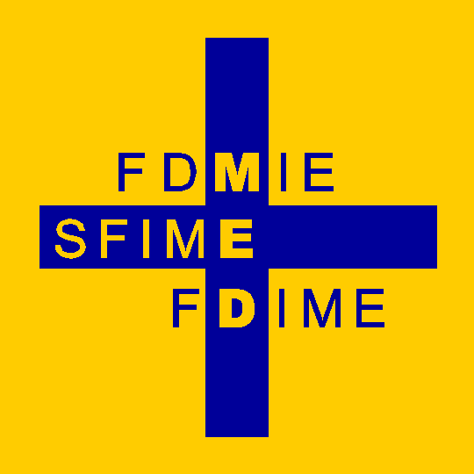 | The Foundation for the Development of Internal Medicine in Europe  and  The European Federation of Internal Medicine | 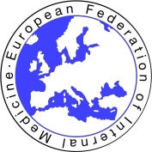

FDIME-EFIM 20th CLINICAL RESEARCH SEMINAR

Paris, 06 – 08 October 2025

Sponsorship for this Seminar is provided by the Foundation for the Development of Internal Medicine in Europe (FDIME). This enables us to offer up to 15 bursaries to Young Internists from EFIM member countries who are interested to develop their career skills in Clinical Research. The bursaries will fund hotel stay for 3 nights and economy-rate travel to Paris. Selected Residents will be required to make their own economy-rate travel booking to Paris. Travel expenses will be refunded after attendance at the Seminar. FDIME will arrange hotel accommodation.

COURSE DATES : Monday 6 October to Wednesday 8 October 2025
(Residents arrive: Sunday 5 October- Residents depart: Wednesday 8 October after lunch)

SEMINAR VENUE : La maison de la Pneumologie, 68 Boulevard Saint- Michel, 75006 Paris

ELIGIBILITY CRITERIA : To be considered for a place at the Seminar aimed at Young Internists, Applicants
must meet the following criteria:-

- Candidates must be under the age of 35 years, be member of a National Society of Internal Medicine affiliated to EFIM. Supporting letters from their supervisor and from a member of the National Society board are mandatory
- Be able to communicate in English (this is essential as all lectures & interaction are in English)
- Be towards the end of their training in Internal Medicine.
- Have current or previous experience of Clinical Research activity

A Motivational Statement is required, also your idea for a new Clinical Research Project (title and short description). We recommend you prepare text for these answers before you start completing the online form. You will also need to upload your CV. Please ensure that your CV is up-to-date and includes references for any publications where you have been author or co-author.

Please proceed to the Online Application Form to see the questions and consider your replies in advance OR download the Application Form.

If you have any difficulty accessing the online form or uploading your CV, please contact Miss Samia Jeanbart email: sjeanbart@yahoo.com
APPLICATION CLOSING DATE: 15.07.2025

The Seminar Selection Committee will assess all applications, and successful applicants will be notified by beginning September 2025.
Selected applicants will be required to prepare a short talk (in English) as an example of clinical research that they are currently undertaking, or recently carried out. This will be a 5 minute slide presentation to the group.

